CREATIVE EDUCATIONAL SERVICES
END OF TERM TWO EXAMINATIONS, 2024
PRIMARY TWO

LITERACY ONE
Name ___________________________________ Stream _______
Date _________________________________
Read and follow the following instructions.
- Answer all questions.
- Write well.
- Wrong spellings will lead to loss of marks.

Section A (40 marks)
- Name the living thing shown below.
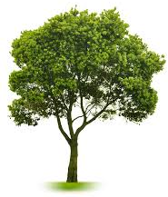

- Why do people sleep under a treated mosquito net?
____________________________________________________________
- Draw a fish.

- Name the main natural source of light in our environment.
___________________________________________________________
- Identify any one way of keeping our toilets clean.
___________________________________________________________
- Why do we wash hands before eating food?
____________________________________________________________
- Mention any one fruit plant in our school compound.
____________________________________________________________
- Give any one use of water to people.
____________________________________________________________
- Mention any one way of caring for domestic animals.
____________________________________________________________
- Name any one garden tool used for harvesting banana.
____________________________________________________________
- How is the item below useful to people?
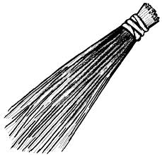

- Name the human body part used for walking?
___________________________________________________________

- Mention any one activity we do after visiting the toilet.
____________________________________________________________
- Give any one way of caring for parts inside the mouth.
____________________________________________________________
- Why do people keep hens at home?
____________________________________________________________
- How is a hoe useful to a farmer?
____________________________________________________________
- Why do cows move from one place to another?
____________________________________________________________
- Why do we need bees in our environment?
____________________________________________________________
- Give any one use of soil to people.
____________________________________________________________
- Which food value protects our bodies from getting diseases?
____________________________________________________________
- How is a razorblade important in keeping personal hygiene?
____________________________________________________________
- Write any one way of caring for our ears.
____________________________________________________________
- How do dogs protect themselves from enemies?
____________________________________________________________
- How do people make their water dirty?
____________________________________________________________
- How do we prevent bad smell from our toilets?
____________________________________________________________
- Why is a stone grouped under non-living things?
____________________________________________________________
- Name any one food stuff eaten at school.
____________________________________________________________
- What is wind ?
___________________________________________________________
- Draw any one item we use when eating food.

- Why is a dustbin important in a classroom?
___________________________________________________________
- Give any one danger of birds to a farmer.
____________________________________________________________
- Identify any two items we use to clean our teeth.
- _______________________________________________________
- _______________________________________________________
- Write any two uses of plants to people.
- _______________________________________________________
- _______________________________________________________

- Mention any two things we use to give first aid.
- _______________________________________________________
- _______________________________________________________
- What is the best food for a two months old baby?
____________________________________________________________
- Give any two uses of electricity at home.
- _______________________________________________________
- _______________________________________________________
SECTION B( 60 MARKS)
- (a) Name any two examples of birds kept at home.
- _______________________ (ii) ____________________________
(b) Give any two ways of caring for domestic animals.
(i) ________________________________________________________
(ii) _______________________________________________________
- (a) Give any two reasons why people eat food.
- ______________________________________________________
- ______________________________________________________
(b) Apart from glow foods, give any other classes of food.
______________________________________________________
- Write any one use of food in our bodies.
_______________________________________________________
- (a) Identify any two activities done by farmers during
rainy/wet season.
- ______________________________________________________
- ______________________________________________________

(b) How are these garden tools useful to a farmer?
(i) hoe ____________________________________________________
(ii) rake ____________________________________________________
- (a) Give any one danger of insects to people.
____________________________________________________________
(b) Write down any one disease spread by these insects.
- housefly _______________________________________________
- mosquito ______________________________________________
- Complete the table correctly.
adult | young ones | home
monkey |  | Small letters
 | duckling | house
 | puppy
pig |  | sty


- Match the parts of a plant correctly.

roots
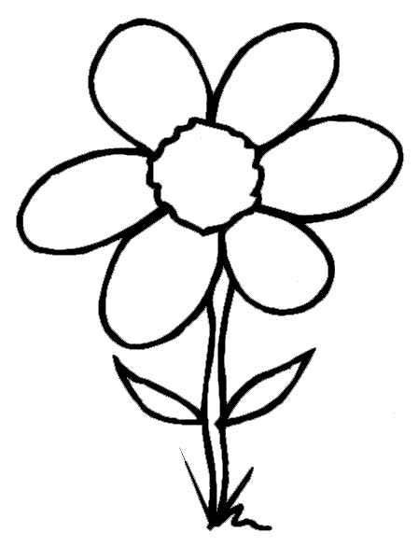
stem

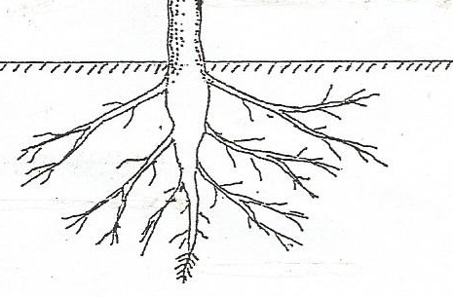
leaf

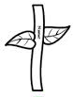
flower

- Identify any two common diseases to people.
- _______________________ (b) __________________________
- From the list given below, underline the four life cycle stages of a housefly.
frogs, eggs, bees, pupa, nymph, butterfly, larva

